|  |  |  |
| --- | --- | --- |
| Parallel and Distributed Computing (6E/6F)  Quiz 01 (Spring 2022) | | Name: ***SOLUTION*** |
| Instructor: Dr. Syed M. Irteza | |
| Date: 2022-03-14 | | Roll Number: |
| Total Marks: 15 | Time Allowed: 10 minutes |

1. The PRAM model that provides the minimum memory access concurrency is? [3m]
   1. Exclusive-read, concurrent-write PRAM
   2. Concurrent-read, concurrent-write PRAM
   3. ***Exclusive-read, exclusive-write PRAM***
   4. Concurrent-read, exclusive-write PRAM
2. We use arbitration protocols for concurrent writes, the protocol which requires all writes to store identical values to be accepted is? [3m]
   1. Sum
   2. Priority
   3. Arbitrary
   4. ***Common***
3. Total communication costs for a message of size ***m*** words and ***tw*** per-word transfer time with packet routing (instead of store-and-forward routing) are reduced by? [3m]
   1. Having no *ts*, i.e., startup time
   2. ***Multiplying twm by 1, not l (where l is the number of communication links)***
   3. Multiplying *twm* by l, not 1 (where l is the number of communication links)
   4. Having a smaller value for l (where l is the number of communication links)
4. We discussed two different metrics for concurrency and looked at two similar examples of task-dependency graphs. What were those two different metrics, and why was it that in those two graphs, one of the metrics was the same, and the other was different for both? [6m]
5. ***Maximum Degree of Concurrency: The maximum number of tasks that can be executed simultaneously in a parallel program at any given time is known as its maximum degree of concurrency***

* ***For task dependency graphs that are trees, the maximum degree of concurrency is always equal to the number of leaves in the tree***

1. ***Average Degree of Concurrency: The average number of tasks that can run concurrently over the entire duration of execution of the program***

* ***The ratio of the total amount of work to the critical path length***

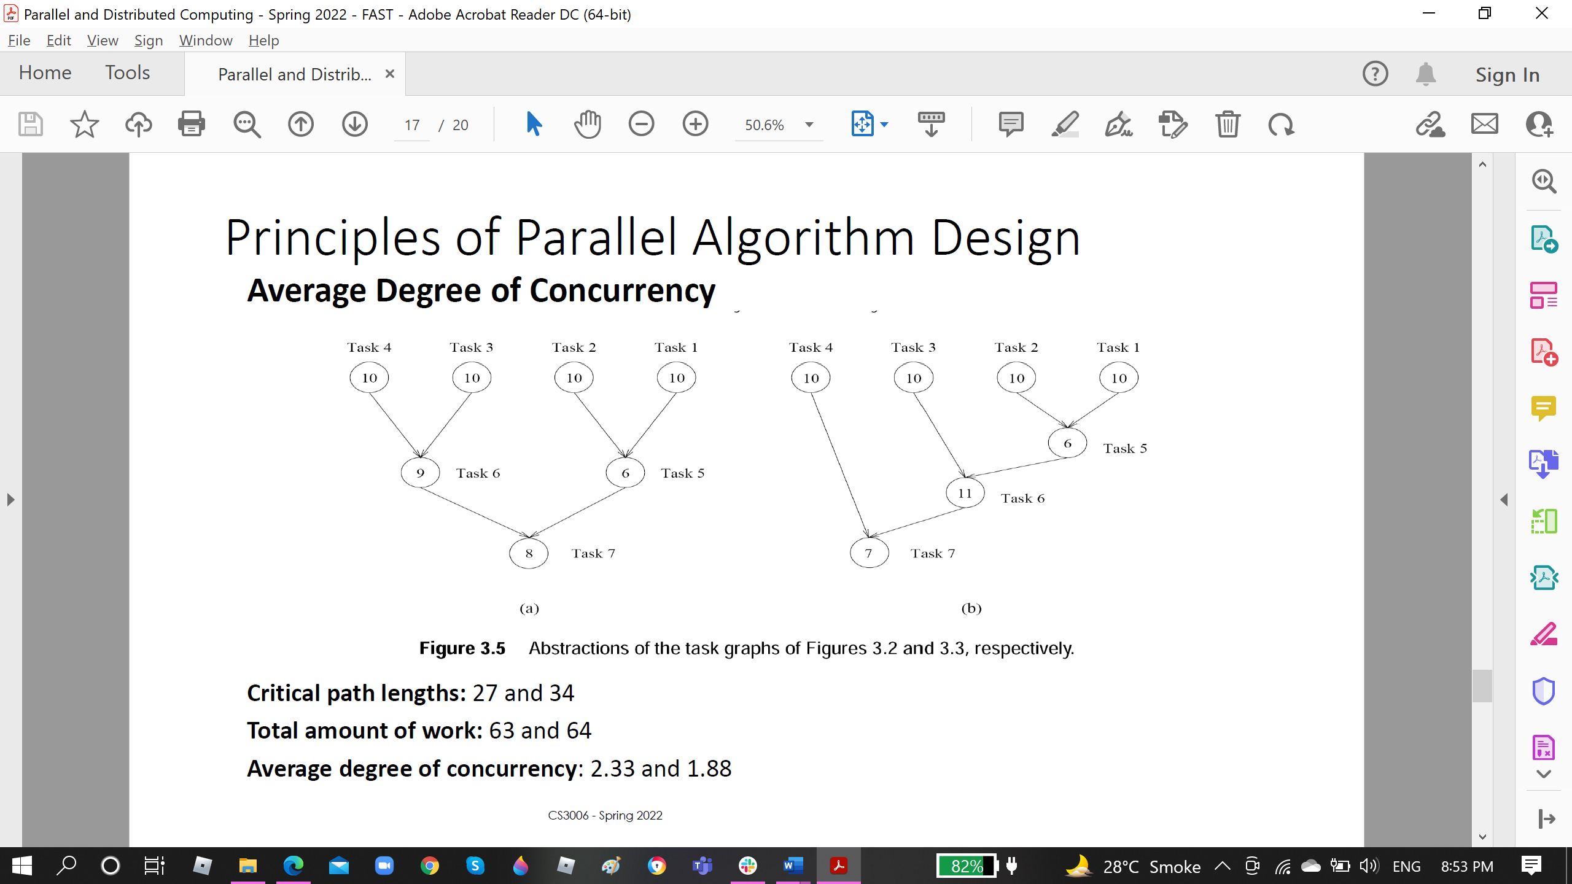

***Here, the max. degree of concurrency was 40 for both (sum of weights of the leaves), however, the avg. degree of concurrency was 2.33 and 1.88 respectively. Clearly the critical path length (34) for the second task-dependency graph is larger than the for the first (27).***